AP Chemistry Pre-Syllabus |  | Instructor: Myriah Day  Phone: 503-916-5260  Email: mday@pps.net  rhsapchem1718.weebly.com
Course Description  The purpose of Advanced Placement Chemistry is to provide a college level course in chemistry and to prepare students to seek credit or appropriate placement in college chemistry courses. The curriculum content, including the lab experiments, is based on the College Board curriculum framework and approved example syllabi released in 2013. This course meets every other day.  Communication  All communication over the summer and outside of class will be conducted via the following:  - Remind: rmd.at/hfcg6e (required to participate in class) - see attached  - Email: mday@pps.net  - Website: rhsapchem1718.weebly.com  - WebAssign (www.webassign.net)  Laboratory Program  Students in this course are required to actively participate in labs. This includes manipulation of all lab equipment, collecting and graphing data, conducting multiple trials, and using statistical analyses of individual and class data to make conclusions. Inquiry is a major component of most experiments that students complete, requiring students to design and implement experiments, and analyze data. For all labs, students are required to submit a lab report for grading that has the following components: purpose, procedure, all data, data analysis, error analysis, summary of results, and a conclusion and discussion section. These reports will be kept in a portfolio of work in a three ring binder, to be graded every 9 weeks and once at the end of the course. In addition, students are required to keep a lab notebook in which they will record all aspects of the investigation: scientific question, purpose, materials, procedure (with diagrams), data (including tables, graphs, diagrams), data analysis and calculations, error analysis, and initial conclusions. Most laboratory experiments are intended to take one full class period of 90 minutes, except the guided inquiry experiments that will require two class periods to complete.  Exams  A mid-term exam is administered approximately every 4.5 weeks, as well as one every quarter, or 9 weeks. All exams are comprehensive, and administered in the same way or as close to the AP Exam as possible.  The final 6 full class periods (2 weeks) before the AP Chemistry Exam are used for exam review and practice tests using old AP Chemistry exam materials. Students work in cooperative groups to solve and present to the class a packet of free response problems from previous exams. In addition, AP Chemistry Practice Exams are administered as part of this review process. |  | Textbook  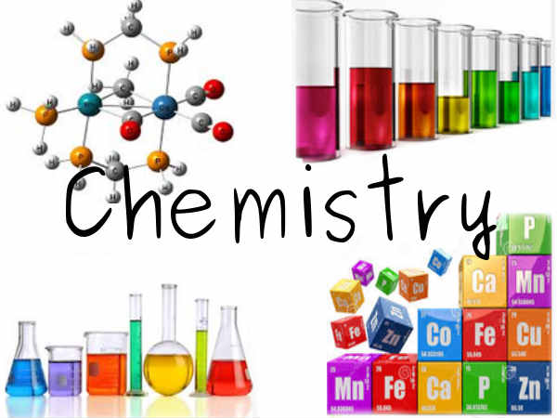  Brown, Theodore L., H. Eugene LeMay, Bruce Bursten, Catherine Murphy, Patrick M. Woodward, Matthew W. Stoltzfus (2015) Chemistry: The Central Science (13th Edition). New Jersey: Pearson Education  Lab Manuals  College Board, AP Chemistry Guided Inquiry Experiments: Applying the Science Practices, 2013  Jack Randall, Advanced Chemistry with Vernier, 2013  Donald L. Volz, Ray Smola, Investigating Chemistry Through Inquiry, 2013  Flinn, Advanced Inquiry Labs for AP Chemistry, 2013  Demonstration Resources  Shakhashiri, Bassam, Chemical Demonstrations: A Handbook for Teachers of Chemistry
Overview of the Year
Unit 1: Introduction to Matter and Measurement (Ch.1)
Unit 2: Atoms, Molecules and Ions (Ch. 2 & 6)
Unit 3: Stoichiometry: Chemical Reactions and Reaction Stoichiometry (Ch. 3)
Unit 4: Reactions In Aqueous Solutions (Ch. 4)
Unit 5: Thermochemistry (Ch. 5)
Unit 6: Periodic Properties of Elements (Ch. 7)
Unit 7: Basic Concepts in Chemical Bonding (Ch. 8)
Unit 8: Molecular Geometry and Bonding Theory (Ch. 9)
Unit 9: Gasses (Ch. 10)
Unit 10: Liquids and Intermolecular Forces (Ch. 11)
Unit 11: Properties of Solutions (Ch.13)
Unit 12: Chemical Kinetics (Ch.14)
Unit 13: Chemical Equilibrium (Ch.15)
Unit 14: Acid-Base Equilibria (Ch.16 & 17)
Unit 15: Chemical Thermodynamics (Ch. 19)
Unit 16: Electrochemistry (Ch. 20)
Unit 17: AP Exam Review

SUMMER ASSIGNMENT - Don’t worry, it isn’t that bad.
- Step 1: Pick up the textbook from the library DURING tutorial
- Step 2: Read the first chapter and do the following practice exercises on a sheet of notebook paper ready to turn in first day of class in September.
  - Page 11: Practice Exercise 1 (End of section 1.2: Classifications of Matter)
  - Page 17: Practice Exercise 2 (Middle of section 1.3: Units of Measurement)
  - Page 18: Practice Exercise 2 (Middle of section 1.3: Units of Measurement)
  - Page 23: Practice Exercise 2 (Middle of section 1.5: Uncertainty in Measurement)
  - *Page 23: Both Practice Exercises 1 (End of section 1.5: Uncertainty in Measurement)
  - Page 29: Practice Exercise 1 (Middle of section 1.6: Dimensional Analysis)
  - Page 30: Practice Exercise 1 (Middle of section 1.6: Dimensional Analysis)
  - Page 31: Practice Exercise 1 (End of section 1.6: Dimensional Analysis)
- Step 3: Memorize the following polyatomic ions and their charges

Phosphate
Phosphite
Sulfate
Sulfite
Nitrate
Nitrite
Hypochlorite
Chlorite
Perchlorate

- Step 4: Register for WebAssign (online summer assignment)
  - Go to: www.webassign.net
  - Enter Class Key: roosevelt.or 7226 8166
  - Select Our Course (AP Chemistry 2017-18)
  - Create Account (if you don't already have one)
  - Sign into your account
  - Find "Summer Assignment 2017-18" and begin assignment
Total number of problems = 40 (including web assignment). All told, it should take you a couple hours to read the chapter and another hour or two to do the problems. This is not that much to do in 3 months!
Strategies to help you: Use the internet and videos to supplement things you don’t understand on the practice exercises (e.g. Enter into google: “What is a significant figure?”); Or email me with questions (I will be available over the summer)
Get it done so you aren’t behind! And remember: YOU ARE AMAZING!

